# Goal:

Create a list that accepts and stores the data from monsters from the Monster Hunter video game series. The database schema stores four pieces of data, excluding the object ID: name *(String*), locale (*String*), description (*String*), and difficulty (*number*).

Monster Hunter is a video game series that I like, which is why I decided to base my database on it. The purpose of the site is to help keep a database of the monsters that the user may encounter in the game.

The website allows the user to perform CRUD operations for the list.   
  
User authentication is not needed. Sanitization is done automatically by MongoDB. The splash page is a modified version of the home page from Professor Ahmed’s videos.

## Splash page:

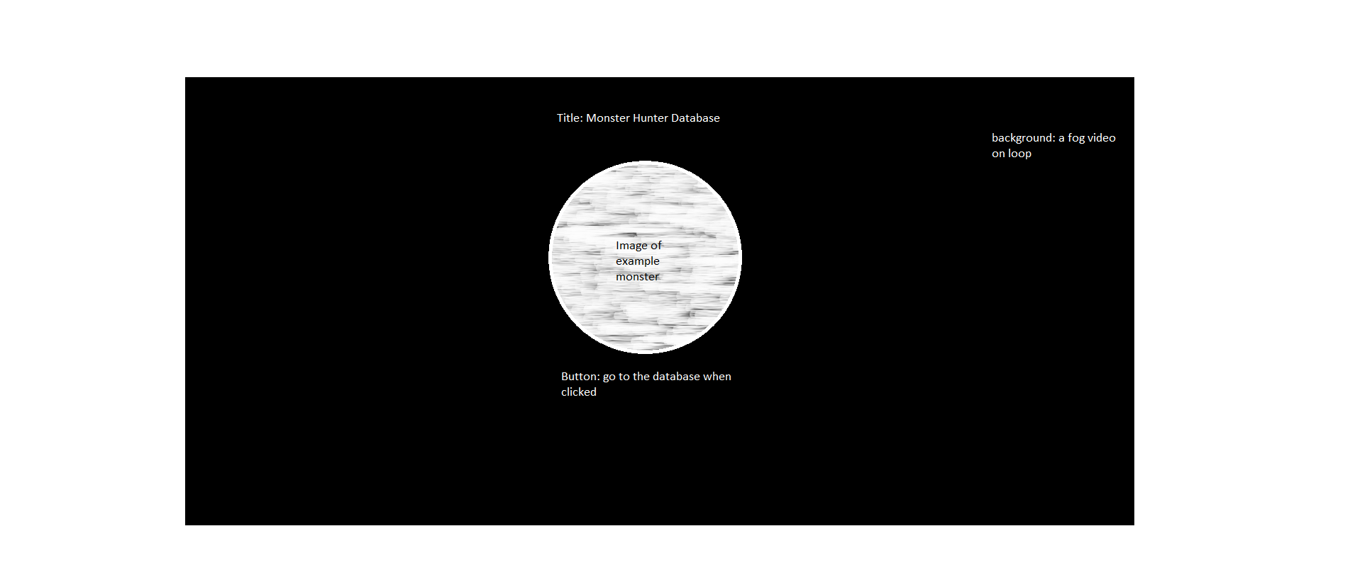

## Database list

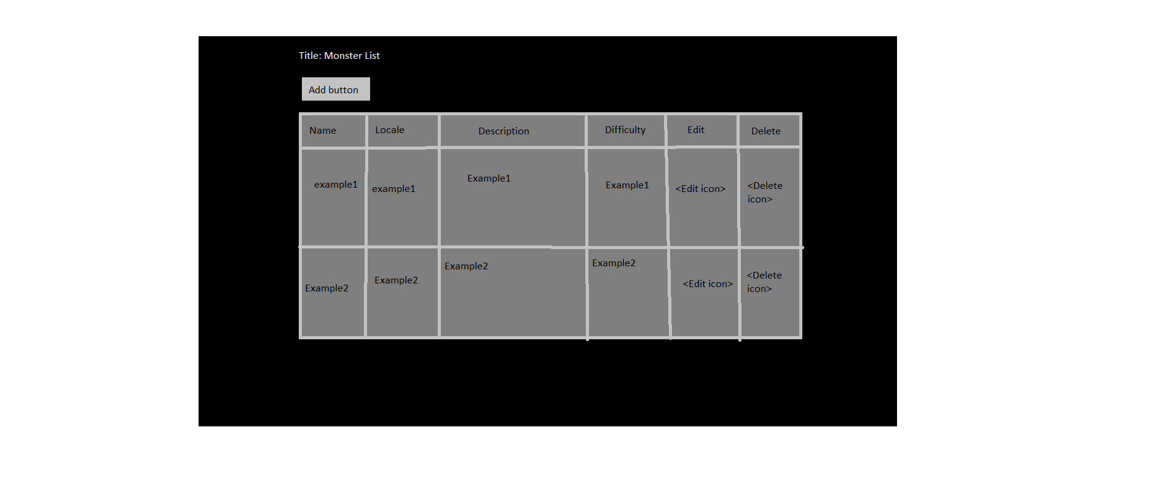

* The background of fog carries over from the splash page.